

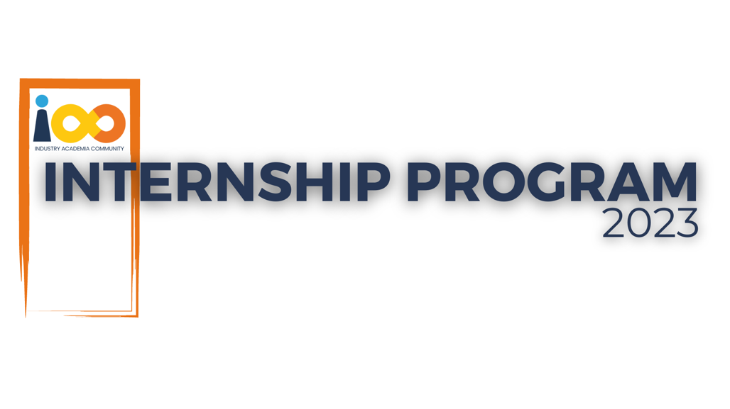

PROJECT REPORT

Machine Learning  
  
Student Graduation and Placement Predictor

|  |  |  |  |
| --- | --- | --- | --- |
| **Created By:** | Abhigyan Bhatnagar | **Approved By:** | Harshada Topale |
| **Created On:** | 11-06-2024 | **Approved On:** | DD-MMM-YYYY |

Page left blank intentionally

**INDEX**

**1** **PROJECT DETAILS** 1

**2** **SUMMARY** 1

**3** **INTRODUCTION** 1

3.1 Background 1

3.2 Stakeholders 1

3.3 Objectives 1

**4** **METHODOLOGY** 1

4.1 Considerations & Assumption 1

4.2 Approach 2

4.3 Activities 2

**5** **TARGETTED V/S ACHIEVED OUTPUT** 2

**6** **CONCLUSION** 2

**7** **APPENDICES** 2

7.1 Appendix A – Title 2

# **PROJECT DETAILS**

|  |  |  |  |
| --- | --- | --- | --- |
| **Project Name** | Student Placement and Graduation Predictor | | |
| **Project Sponsor** | Tushar Topale | | |
| **Project Manager** | Harshada Topale | | |
| **Start Date** | 11-06-2024 | **Completion Date** | 01-07-2024 |

# **SUMMARY**

*The project consists of solving two problems. The first one deals with predicting the placement status of the student, it is solved using a machine learning model. The second one aims to calculate the year of graduation of the student based on given data.*

# **INTRODUCTION**

## Background

*Lack of clear academic planning and career advice is the root cause of the issue with students not knowing when they will graduate and not receive a placement. Without timely updates on their graduation status, students may struggle to complete their coursework on schedule. Additionally, without prior knowledge of the skills required for specific placements, individuals might not be adequately prepared for the job market.*

## Stakeholders

Project Sponsor- Tushar Topale

## Objectives

*The first objective is to predict the placement status of a student based on factors such as ‘College name’, ‘ML Knowledge’, ‘Speaking Skills’, ‘CGPA’ using a model that gives a highly accurate value.*

*The second objective is to calculate the year of graduation of a student based on current academic year*

# **METHODOLOGY**

These conventions are all about the positions of line breaks, how many characters should go on a line, and everything in between.

## Considerations & Assumption

*1) Assumed null entries under the ‘Placement Status’ column to be ‘not placed’ for training the model.*

*2) In case of duplicate e-mail ids, only the latest entry was considered.*

## Approach

*Developed the machine learning model using a Decision Tree Classifier from Python’s sci-kit learn library for placement prediction whereas the year of graduation model was built upon a mathematical formula.*

## Activities

*Understanding the problem statement*

*Resource Gathering*

*Project Preparation*

*Project Testing*

*Deployment*

# **TARGETTED V/S ACHIEVED OUTPUT**

*The machine learning model achieved an accuracy of 0.99 which corresponds to an accuracy rate of 99%.*

# **CONCLUSION**

*The project was successfully developed in order to solve the tasks of placement prediction and year of graduation calculation*

# **APPENDICES**

## Appendix A – Title

-